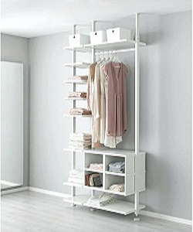

Modern Wall Divider

$150.32

Availability: In stock

**Description:**

White Stainless divider with Shelves and Drawers with integrated dampers close slowly, silently and softly. this room divider can be used to define space in an open concept room, or can be set in front of a large window for privacy. Rounding out the design, metal hinges make folding and storage a breeze when not in use.